**Web design assignment**

**Module(JQuery Basic, Effects & Advanced)-5**

**(1)what is jQuery?**

* **Ans.:-** jQuery is a fast and concise JavaScript Library created by John Resig in 2006 with a nice motto: Write less, do more. jQuery simplifies HTML document traversing, event handling, animating, and Ajax interactions for rapid web development

jQuery is an open source JavaScript library that simplifies the interactions between an HTML/CSS document, or more precisely the Document Object Model (DOM), and JavaScript. JQuery lets users develop Ajax templates with ease, Ajax enables a sleeker interface where actions can be performed on pages without requiring the entire page to be reloaded.

**(2) How to Apply CSS Using JQuery, How to Add Class and Remove Class in Jquery ,**

**JQuery Animation?**

* **Ans.:-** jQuery has several methods for CSS manipulation. We will look at the following methods:
* **addClass() method:-** It is used to add specified classes to each of the targeted elements while animating all style changes.
* **Example:-**
* **Input:-**

!DOCTYPE html>

<html lang="en">

<head>

<meta charset="UTF-8">

<meta http-equiv="X-UA-Compatible" content="IE=edge">

<meta name="viewport" content="width=device-width, initial-scale=1.0">

<title>Document</title>

<script src="https://cdnjs.cloudflare.com/ajax/libs/jquery/3.6.4/jquery.min.js"></script>

<!-- CSS STYLE START -->

<style>

.first{

background-color: blue;

color: brown;

}

</style>

<!—CSS STYLE END -->

</head>

<body>

<!-- HTML START -->

<p>how are you</p>

<h1>hiii hello</h1>

<h4>Lorem ipsum dolor sit amet consectetur adipisicing elit. Vel, enim.</h4>

<button>paresh</button>

<!-- HTML END -->

<!-- JAVASCRIPT START -->

<script>

$(document).ready(function () {

$("button").click(function () {

$("p,h1,h4").addClass("first")

})

})

</script>

<!-- JAVASCRIPT END -->

</body>

</html>

* **Output:-**

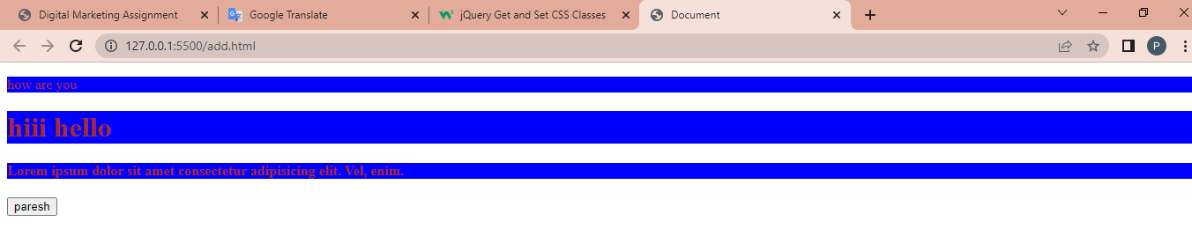

* **removeClass() method**:- It is used to remove the classes from the element while animating all style changes.
* **Example:-**
* **Input:-**

<!DOCTYPE html>

<html lang="en">

<head>

<meta charset="UTF-8">

<meta http-equiv="X-UA-Compatible" content="IE=edge">

<meta name="viewport" content="width=device-width, initial-scale=1.0">

<title>Document</title>

<script src="https://cdnjs.cloudflare.com/ajax/libs/jquery/3.6.4/jquery.min.js"></script>

<!-- CSS STYLE START -->

<style>

.one{

background-color: brown;

color: cornflowerblue;

}

</style>

<!-- CSS STYLE END -->

</head>

<body>

<!-- HTML START -->

<p class="one">

Lorem ipsum dolor sit amet, consectetur adipisicing elit. Dolorum tempore quia tenetur reprehenderit tempora

maiores ratione architecto, amet ullam natus vero consequatur neque magnam, quod aspernatur, fuga dolores

accusantium sapiente eius doloribus cumque. Blanditiis!

</p>

<h1 class="one">paresh</h1>

<h4 class="one">solanki</h4>

<button>kkjkkk</button>

<!-- HTML END -->

<!-- SCRIPT START -->

<script>

$(document).ready (function () {

$("button").click (function () {

$("p,h4").removeClass ("one")

})

})

</script>

<!-- SCRIPT END -->

</body>

</html>

* **Output:-**

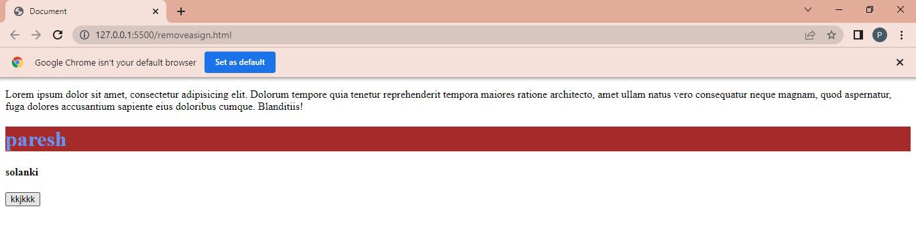

* **Jquery animation :-**
* **Input:-**

<!DOCTYPE html>

<html lang="en">

<head>

<meta charset="UTF-8">

<meta http-equiv="X-UA-Compatible" content="IE=edge">

<meta name="viewport" content="width=device-width, initial-scale=1.0">

<title>Document</title>

<script src="https://cdnjs.cloudflare.com/ajax/libs/jquery/3.6.4/jquery.min.js"></script>

<!-- STYLE START -->

<style>

#myDiv {

width: 200px;

height: 200px;

background-color: blue;

}

</style>

<!-- STYLE END -->

</head>

<body>

<!-- HTML START -->

<h1>jQuery Animation Example</h1>

<div id="myDiv"></div>

<!-- HTML END -->

<!-- JAVASCRIPT START -->

<script>

// jQuery code starts here

$(document).ready(function () {

var $myDiv = $("#myDiv");

// Define the animation

$myDiv.click(function () {

$myDiv.animate({

width: "400px",

height: "400px",

backgroundColor: "blue"

}, 1000, function () {

// Animation complete

$myDiv.animate({

width: "200px",

height: "200px",

backgroundColor: "red"

}, 1000);

});

});

});

</script>

<!-- JAVASCRIPT END -->

</body>

</html>

* **Output:-**

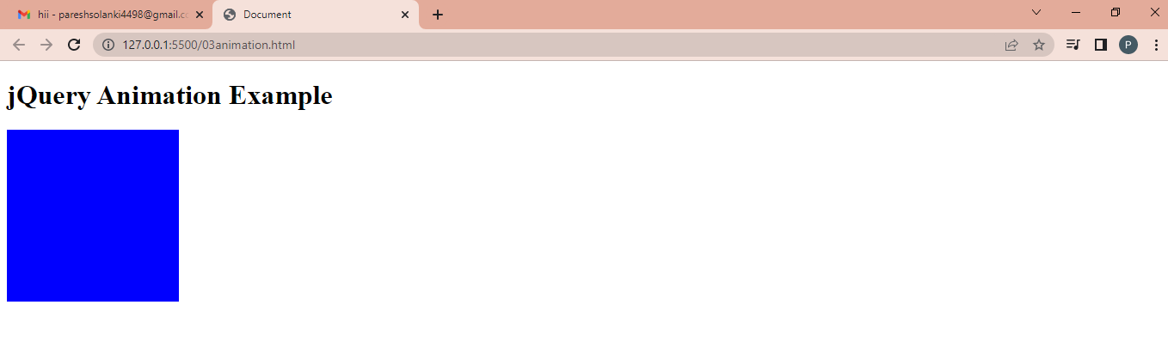

**(3) How to create slider with animation?**

* **ANS.:-** jQuery animate ( ) Method
* The method used to create custom animations called the jQuery animate ( ) method. This type of method used to animate numeric CSS properties, like, width, height, margin, opacity, top, left, and padding.
* **Example:-**
* **Input:-**

<!DOCTYPE html>

<html lang="en">

<head>

<meta charset="UTF-8">

<meta http-equiv="X-UA-Compatible" content="IE=edge">

<meta name="viewport" content="width=device-width, initial-scale=1.0">

<title>Document</title>

<script src="https://cdnjs.cloudflare.com/ajax/libs/jquery/3.6.4/jquery.min.js"></script>

<!-- STYLE START -->

<style>

.slide{

height: 200px;

width: 200px;

background-color: chartreuse;

margin: 5px;

}

</style>

<!-- STYLE END -->

</head>

<body>

<!-- HTML START -->

<div id="slider">

<div class="slide">Slide 1</div>

<div class="slide">Slide 2</div>

<div class="slide">Slide 3</div>

</div>

<!-- HTML END -->

<!-- JAVASCRIPT START -->

<script>

$(document).ready(function () {

var slider = $('#slider');

var slides = $('.slide');

var currentIndex = 0;

// Set the initial slide

slides.eq(currentIndex).show();

// Function to animate the slides

function animateSlides() {

// Fade out the current slide

slides.eq(currentIndex).fadeOut();

// Increment the index

currentIndex++;

// Wrap around to the first slide if necessary

if (currentIndex >= slides.length) {

currentIndex = 0;

}

// Fade in the next slide

// slides.eq(currentIndex).fadeIn();

}

// Set an interval to animate the slides every 3 seconds

setInterval(animateSlides, 2000);

});

</script>

<!-- JAVASCRIPT START -->

</body>

</html>

* **Output:-**

